Task 1: Creating VLANs 'Sales' and 'Support'

Objective: Create two VLANs on a Cisco switch:
- VLAN 10 → Sales
- VLAN 20 → Support
Cisco Packet Tracer Commands:
Switch> enable
Switch# configure terminal
Switch(config)# vlan 10
Switch(config-vlan)# name Sales
Switch(config-vlan)# exit
Switch(config)# vlan 20
Switch(config-vlan)# name Support
Switch(config-vlan)# exit
Switch(config)# end
Switch# show vlan brief
VLANs:
VLAN ID | VLAN Name | Purpose
10 | Sales | Sales department
20 | Support | Support department

Task 2: Assigning ports and verifying VLAN membership

Three ports will be assigned to Sales VLAN 10:
- Fa0/1
- Fa0/2
- Fa0/3
Two ports will be assigned to Support VLAN 20:
- Fa0/4
- Fa0/5
Configure Sales VLAN
Switch# configure terminal
Switch(config)# interface range fa0/1-3
Switch(config-if-range)# switchport mode access
Switch(config-if-range)# switchport access vlan 10
Switch(config-if-range)# exit
Configure Support VLAN
Switch(config)# interface range fa0/4-5
Switch(config-if-range)# switchport mode access
Switch(config-if-range)# switchport access vlan 20
Switch(config-if-range)# exit
Switch(config)# end
Switch# show vlan brief
Result:
Switch# show vlan brief
VLAN Name Status Ports
-------- ---------- --------- --------------------------------------------
10 Sales active Fa0/1, Fa0/2, Fa0/3
20 Support active Fa0/4, Fa0/5
The show vlan brief command verifies that the ports have been assigned to the correct VLANs.

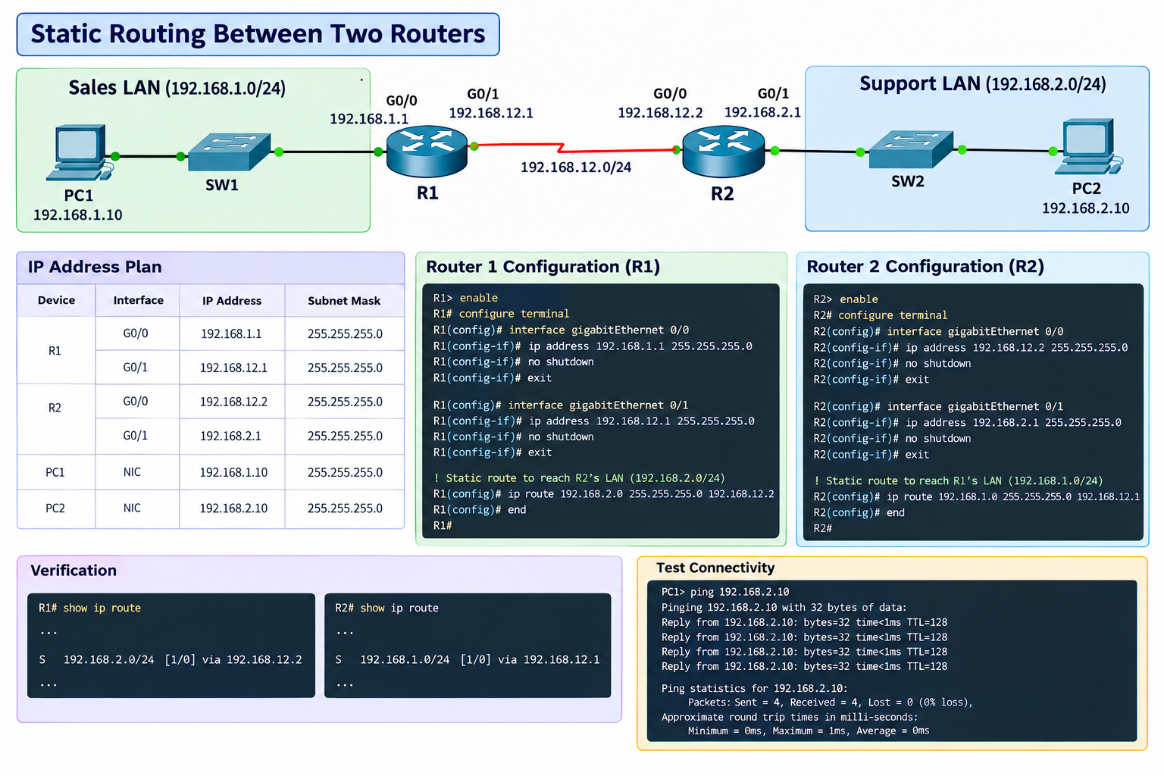
Task 3: Configure Static Routing Between Two Routers

Add Static Route on Router 1
The LAN behind Router 2 is 192.168.2.0/24.
R1(config)# ip route 192.168.2.0 255.255.255.0 192.168.12.2
This tells Router 1 to send traffic destined for 192.168.2.0/24 through Router 2 at 192.168.12.2.
Add Return Route on Router 2
To allow the reply to return to the Sales LAN:
R2(config)# ip route 192.168.1.0 255.255.255.0 192.168.12.1

Task 4: Intra-VLAN vs. Inter-VLAN Ping Failure Analysis

Why the Ping Fails:
- A VLAN partitions a physical switch into distinct, isolated Layer 2 broadcast domains.
- A host in the Sales VLAN (VLAN 10) belongs to a different logical IP subnet and broadcast domain than a host in the Support VLAN (VLAN 20).
- Standard Layer 2 switches forward traffic using only MAC addresses within the same VLAN tag; they cannot inspect Layer 3 IP headers or forward frames across different VLAN boundaries. Because no routing device bridges the two broadcast domains, packets destined for the other VLAN are dropped.
Solutions for Inter-VLAN Communication:
- Router-on-a-Stick (ROAS):
- Configure an 802.1Q trunk link between the switch and an external router interface.
- Divide the physical router interface into sub-interfaces (e.g., GigabitEthernet0/0.10 and GigabitEthernet0/0.20) with 802.1Q VLAN encapsulation, assigning each the default gateway IP for that respective VLAN.
- Configuration Snippet:
! Switch Trunk Port
Switch(config)# interface GigabitEthernet0/1
Switch(config-if)# switchport mode trunk
! Router Sub-interfaces
Router(config)# interface GigabitEthernet0/0.10
Router(config-subif)# encapsulation dot1Q 10
Router(config-subif)# ip address 192.168.10.1 255.255.255.0
Router(config)# interface GigabitEthernet0/0.20
Router(config-subif)# encapsulation dot1Q 20
Router(config-subif)# ip address 192.168.20.1 255.255.255.0

- Multilayer / Layer 3 Switch (Switch Virtual Interfaces - SVI):
- Enable IP routing directly on a Layer 3 switch (ip routing) and create virtual router interfaces for each VLAN (interface vlan 10, interface vlan 20), allowing hardware-speed inter-VLAN packet switching without needing an external router.

